Andersson Jacob, Johansson Tim, Wikström Leo, Åsbrink Anton

2018-04-09

Use case overview for Warehouse system

**Assignment 1 PA1435 Objektorienterad design**

| **Author Name** | **Personal identity Number** | **Thinking** | **Writing** |
| --- | --- | --- | --- |
| Andersson Jacob |  | 20% | 10% |
| Johansson Tim | 970718-3472 | 45% | 62% |
| Wikström Leo | 970523-6611 | 5% | 3% |
| Åsbrink Anton | 970428-0135 | 30% | 25% |

# Description of system

This system is meant for handling warehouses and their contents, the warehouses are supposed to host trucks and goods. Users (Managers and truckers) are meant to use this system in a way that the managers can assign work for truckers. Both actors will be able to manipulate objects (warehouses, trucks and goods) to some extent.

# Use case diagram

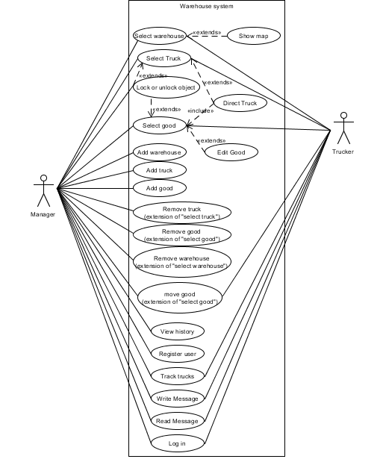

Figure , Use case diagram

# Description of actors

For this system we have identified two actors: Manager and Trucker. The manager actor is the user who will have most control over the system.

A manager will be able to add, remove and edit warehouses, goods, trucks. Manager will also be able to add users to the system, making sure that a manager is the only one who gives authority to anyone.

A trucker will be a user who works in the warehouses. They will be able to edit some goods, though not add or remove goods from the list.

# High-level Use cases

The following is a list of all our use cases for the assignment. They are written as follows:

A name that describes the use case. All actors who will be in contact with the use case. Finally a description about what the use case is meant for. The description also states if a use case has a relation to another use case.

We have a total of 20 use cases:

|  |
| --- |
| Name: ”Show map”  Actor: Manager, Trucker  Description: The user selects an option from the menu, the system responds by displaying a 2-dimensional map of the currently selected warehouse (”Select warehouse”) |

|  |
| --- |
| Name: ”Select warehouse”  Actor: Manager, Trucker  Description: The user enters a warehouse ID, the system responds by displaying information about the warehouse and the system also saves the warehouse as the currently selected warehouse. |

|  |
| --- |
| Name: ”Add good”  Actor(s): Manager  Description: The user enters necessary information for the goods, the system responds by adding the good to the currently selected warehouse. |

|  |
| --- |
| Name: ”Track Trucks”  Actors(s): Manager, Trucker  Description: The system displays a list of all trucks with necessary information about them. |

|  |
| --- |
| Name: ”Select Truck”  Actor(s): Manager, Trucker  Description: The user inputs a truck ID, the system responds by saving the truck as the currently selected truck. |

|  |
| --- |
| Name: ”Select good”  Actor(s): Manager, Trucker  Description: The user inputs a good ID, the system responds by displaying information about the good and saves the good as the current good |

|  |
| --- |
| Name: ”Direct truck”  Actor(s): Manager, trucker  Description: The user selects a truck (”Select Truck”) and a good (”Select good”), the system responds by saving the truck’s destination as the selected good. |

|  |
| --- |
| Name: ”Edit good”  Actor(s): Manager, Trucker  Description: The user selects a piece of goods (”Select good”), the system responds by asking the user for input about changes for the good’s necessary information. The user responds by inputing information about the good, the system saves changes for the piece of goods. |

|  |
| --- |
| Name: ”Lock or unlock object”  Actor(s): Manager  Description: The user selects a truck (”Select truck”) or a good (”Select good”). The system responds by displaying the current status of the object and asks the user if the object should change its status (as locked or unlocked). The user responds by input and the system saves the new status of the object accordingly. |

|  |
| --- |
| Name: ”Write message”  Actor(s): Manager, Trucker  Description: The user inputs text, the system responds by saving this message. |

|  |
| --- |
| Name: ”Read messages”  Actor(s): Manager, Trucker  Description: The system displays all saved messages in an order of when they each were saved. |

|  |
| --- |
| Name: ”Remove good”  Actor(s): Manager, trucker  Description: The system removes the selected goods (”select goods”) from the warehouse/application |

|  |
| --- |
| Name: ”Add warehouse”  Actor(s): Manager  Description: The system adds a warehouse with information provided by the user |

|  |
| --- |
| Name: ”Edit warehouse”  Actor(s): Manager  Description: the system asks user to input new information about the warehouse, the system then saves this new information |

|  |
| --- |
| Name: ”Remove warehouse”  Actor(s): Manager  Description: The system removes the selected warehous (”select warehouse”) |

|  |
| --- |
| Name: ”View history”  Actor(s): Manager  Description: The system displays all actions taken by other users earlier |

|  |
| --- |
| Name: ”Add Truck”  Actor(s): Manager  Description: The user adds a truck, which the system adds to a list. |

|  |
| --- |
| Name: “Log in”  Actor(s): Manager, Trucker  Description: The user logs in to the system by entering a password and a username, the system responds by adding appropriate status and granting him/her the rights reserved to the users status. |

|  |
| --- |
| Name: “Register user”  Actor(s): Manager  Description: The user inputs necessary information and adds a new user to the system, the system saves this information and hashes/secures the information about the users and/or their passwords. |

|  |
| --- |
| Name: “Move Good”  Actor(s): Manager, Trucker  Description: The user moves a selected good (“Select good”) item on the map using the cursor keys. |